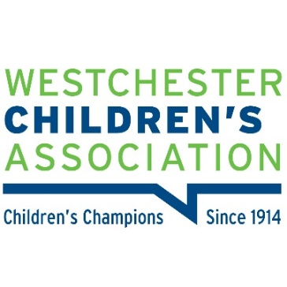
FOR IMMEDIATE RELEASE
Media Contact:
Risa B. Hoag, GMGPR, 845-627-3000, risa@gmgpr.com

Westchester Children's Association’s Home Visiting Awareness
Campaign Quilts Revealed

WESTCHESTER COUNTY, N.Y. (October 3, 2022) – Last week, the Westchester Children's Association (WCA) unveiled five quilts from their Hope Quilt Project at the Westchester Children’s Museum at Playland Park in Rye. The year-long project was developed to raise awareness of the importance of early childhood supports.

“Early childhood home visiting programs provide essential services to families to foster the healthy development of babies,” says WCA Executive Director Allison Lake. “But because of the lack of funding, only four percent of new parents and their infants who need the support of trained professionals can participate in these programs. The Hope Quilt Project was created to enlist the community in creating quilt patches with messages and pictures of hope and engaged volunteers and sponsors to support the funding and WCA’s advocacy work.”
“This was a win-win partnership with WCA,” says Nicole Lotto, supervisor of the Westchester Children’s Museum. “We are delighted to have five of the quilts on display as a testament to the communal effort made to provide extra support to help infants and young parents in the County.”
Donna Green, of the Village Squares Quilters in Scarsdale who completed the quilts, presented them at the event. Speakers included Jewel Williams-Johnson of the Westchester County Board of Legislators, chair of the health committee, John Befus Deputy Commissioner at DSS who spoke on the benefits of home visiting, Cara Stanley from Andrus/Healthy Families, Shannon Von Loon from WJCS and WCA’s Angel Gray.
“Regardless of their Zip codes it’s time to commit and increase access to these programs for both maternal and infant/child wellbeing, while also ensuring that Westchester youth are healthy, safe and prepared for all of life’s obstacles regardless of their Zip codes or background,” stated Angel Gray Program and Policy Manager of the Westchester Children’s Association.
The quilts will hang in the Children’s Museum at Rye Playland for a few months.
Members of the Village Squares Quilters include people at all quilting levels who come together to learn from each other via lectures, workshops, and one-on-one guidance. The organization also distributes hundreds of quilts yearly to nursing homes, veterans, children, and residents of shelters, and teaches quilt-making to new mothers at Bedford Hills Correctional Facility. For more information visit www.Villagesquaresquilters.com

About Westchester Children’s Association
Westchester Children’s Association (WCA) is a multi-issue, child advocacy nonprofit that works to ensure that every child in Westchester is healthy, safe, and prepared for life’s challenges. Since 1914, WCA has been the leading independent voice for Westchester’s children by identifying their needs, making those needs known to the public, and ensuring those needs are met through advocacy and mobilization efforts. For more information about Westchester Children’s Association services, visit their website at www.wca4kids.org.

# # #

